Chat-Bot For College Management System

**Susan Subedi**1 **, Saksham Subedi2 , Sonam Gurung3 , Prashant Sapkota4 ,**

1, 2, 3, 4 Students, Diploma In Information Technology

Narayani Model Collage,Chitwan

***Abstract-*** In this paper, a proposal is explain to design a chat bot as an Web application which will be helpful for students to solve all the problems they face and the questions which arises in their mind during and after the admission. This proposal explains the implementation of chat bot system as an application named as, college enquiry chat bot.

# INTRODUCTION

Chat-bot also known as a talkbot, chatterbox, Bot is a computer program that mimics human conversations[1]. A bot is a software which performs tasks automatically. Basically a bot is a computer program designed for communication and to get answers through that communication[4].

Most of the Chat-bots are developed using Artificial Intelligence algorithms. This system is designed in such a way that it will give answers to user’s queries. This web application will provide the appropriate answers to user’s queries. The answers will be provided using it’s stored database and algorithms used to analyze queries. The user have to register and then login to the bot. After login user can see the page on which queries can be submitted to get answers So, users don’t

need to go personally to the college for inquiry[2].Chat-bots are created by the programmer and designed to have communication and to get answers for queries.

# LITERATURE SURVEY

literature survey is based on some previously available chat-bots as follows:

* 1. ELIZA- ELIZA was a first chatbot which was developed in 1964.in which MAD-slip technology was used. It gives reply in the form of text.
  2. Tech Crunch- Tech crunch was developed in 2005. In this bot Crunch base dataset technology was used. It gives reply in the form of text, voice as well as attachment.
  3. Alexa- Alexa was developed in 2015 by Amazon Lab126. It used NLP, TTS, STT python, Java technology. Alexa gives reply in the form of voice only.
  4. Google assistant- It’s Developed in 2016by Google. It uses NLP., Machine learning. It gives reply in the form of Voice.[3]

1

# METHODOLOGY

Chat-bots are designed to provide communication between human and machine. Admin feeds information to chat-bot as a database so that machine can identify the sentences and take decision itself to answer a question as a response. The function of connecting chat-bot to the database is done by MySQL. In the pattern-matching operation Knowledge representation and implementation of SQL are needed.. To provide response based on user Submitted questions, database is checked using some validation algorithm. If in case any questions in the query did not match to stored database then it will be notify to the admin then admin will work on that or it will add that query/output.

Chat-bots can be identified as information accessing systems as they try to answer questions directly instead of just giving some document links. The aim is to provide exact information related to user submitted queries. So, the chat-bot is implemented using a pattern- matching chat-bots technology.

This paper gives a simple way of building a chat-bot which can provide answer to the user. It will receive a "input" as a plain text and send "output" through process which is able to answer appropriately to questions. Answers will be provided related to that specific word through its available database. The purpose is to provide a solution to the problem.

# PROPOSED SYSTEM

## User Login

The user needs to register to the bot and then login to the bot. After login user can see the page on which queries can be asked and submitted to get answers.

## Responding System

**A. Search Questions in knowledge database:** we have used Auto complete Mechanism in chatbot to provide the users a list of questions while typing the beginning word in the text box. It facilitates the user to select an item from the list, which will be displayed in the input field then the exact question in the database is detected using stored procedure in SQL.

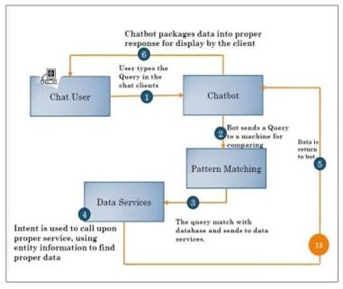

*Figure 1 Architecture Diagram*

## Answer to Complaints

Whenever user submits a question or query, the exact question/queries detected. Then chat-bot checks for the query in the database if it is already there or not in the database. If the answer is available in database then answer is sent

2

to the User. If question is not present in the database, user will get response as invalid question. And such questions are forwarded to admin person. Admin can have a look on such user submitted questions and if those questions are found to be valid then information related to such questions can be stored in the database by the admin person[5]. So that such questions can get answered directly from the database(whenever asked). Because of this admin just have to answer the question only once, No need to answer manually again and again.

# LANGUAGES

## FRONT END

* + **ASP.NET MVC** the controller decides how to render view, meaning which values are accepted from View and which needs to be sent back in response. **ASP**.**NET MVC Session** state enables you to store and retrieve values for a user when the user navigates to other view in an **ASP**.**NET MVC** application

## JAVASCRIPT

We use JavaScript in our project for validation purpose.

## BACK END

* + **Microsoft SQL Server 2017** Talking about SQL server SQL Server is all about database server provided by Microsoft. The most important functions of SQL

Server is to give data to other software applications. To communicate with SQL Server databases and manage or query their data. And this applications will run on the same or a different computer.

## FLOW DIAGRAM OF CHATBOT

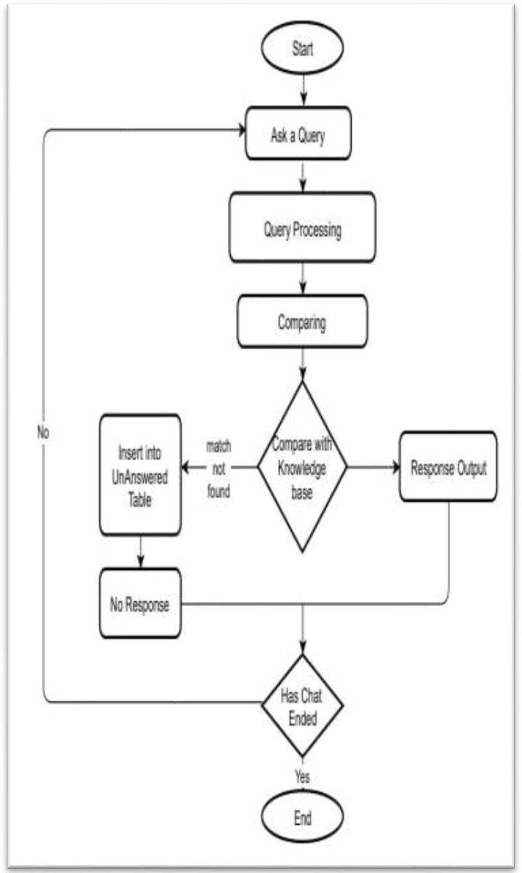

*Figure 2 Flow Diagram Of Chatbot*

3

# OUTPUT SCREENS

* 1. **HOME PAGE**

We can see this home page after opening the Chat-bot.

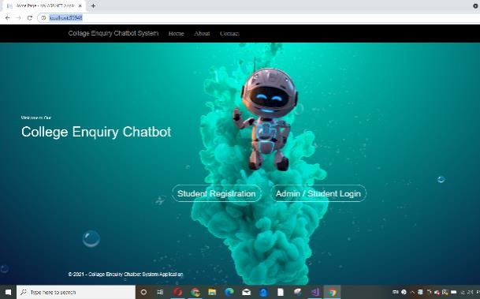

*Figure 3 Home Page*

* 1. **REGISTRATION PAGE**

This is our Registration page. On which we can register on chat-bot by entering all the details. Including Name, E-mail ID, Phone no., etc.

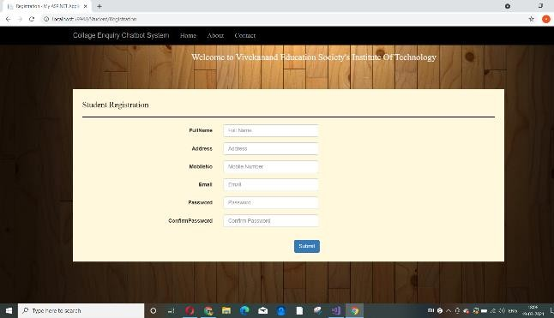

*Figure 4 Registration Page*

* 1. **LOGIN PAGE**

To ask any question to the bot it is necessary to get login here.

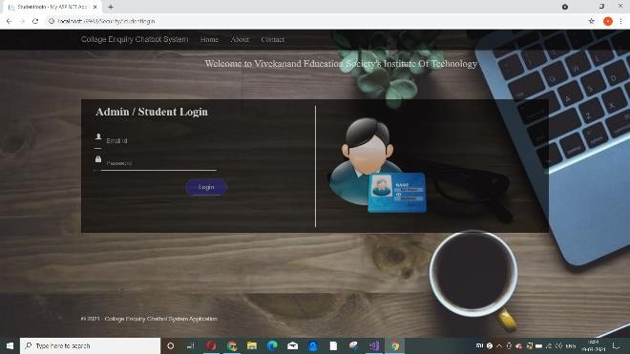

*Figure 5 Login Page*

* 1. **CHATBOT PAGE**

This page is used to ask any question to the chat-bot. Users can put their query here and search for the same.

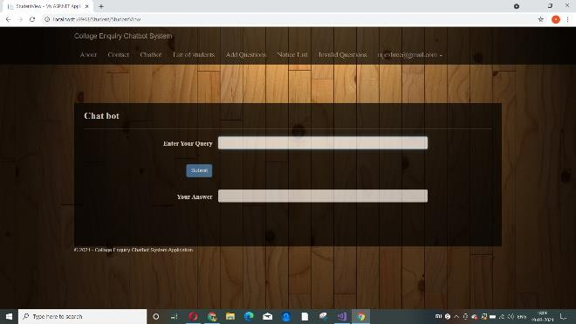

*Figure 6 Chatbot Page*

4

* 1. **NOTICE LIST**

Notice window shows all the collage notifications. which is added by the Admin. And user can easily download the notice by clicking on download

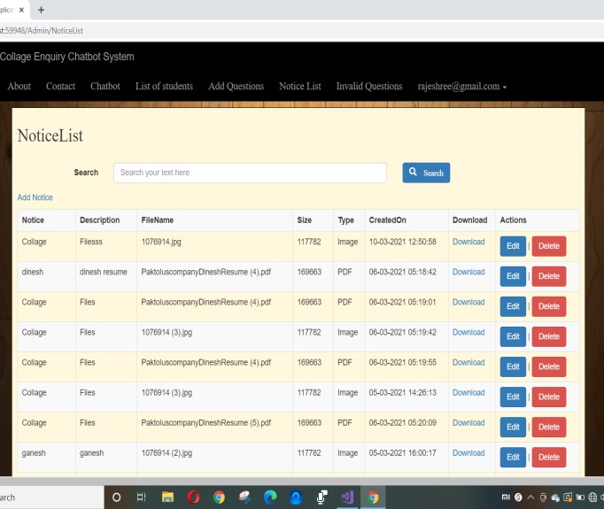

*Figure 7 Notice List*

* 1. **DIRECT ANSWER TO QUESTION**

Users get there answers here from available database.

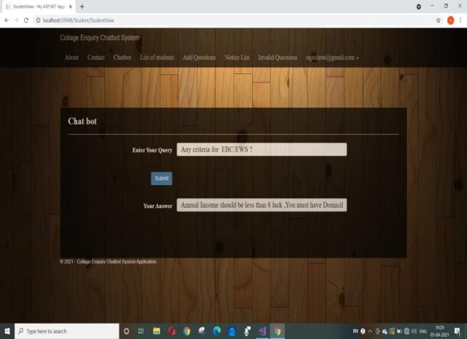

*Figure 8 Direct Answer To Question*

* 1. **RECOMMENDATION OF QUESTIONS**

When user tries to ask their query ,bot provides them some related questions from database.

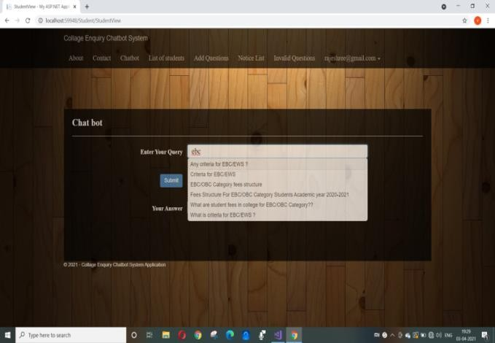

*Figure 9 Recommendation Of Question*

* 1. **PENDING QUESTION**

When user ask any question which is not available in the database, bot ask to user whether he wants to submit the question to admin or not. If user submit the question to admin then that question will be visible in pending questions till admin himself add the answer for the same question

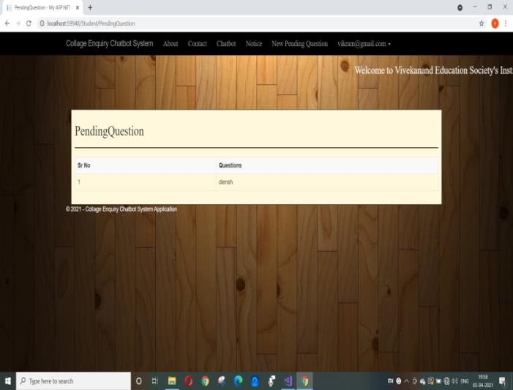

*Figure 10 Pending Question*

5

# LIMITATIONS OFCHATBOT[3]

Conversations with bots lack flow, it often fails to resolve the primary issues. To understand the pitfalls and shortcomings of the chatbot, we can implement a stronger messaging strategy for the future. There are some of the main challenges developers are currently facing.

* Users way of writing text

Everyone has own way of typing, so how to understand user intention is a very challenging task.

* Users way to speak their language

Different end-users have different ways of writing the text on chat. But a Chatbot often doesn't understand it, and sometimes it doesn't give enough time for the human to explain the issue.

* The randomness of being a human

Human behavior is different from emotions but it is very strongly influenced by them. So, do the way they express in messages. In this mood plays a huge role. Users may expect bot to recommend related questions very next moment or they may want to do less typing and get suggestion for desired question. So being prepared for randomness of human being helps.

* Others

Chatbot asks many questions and if there is form then it is compulsory to fill the form there are no other options available.

Some bots have predefined options which they can answer, there are no options where the user can write their query.

# CONCLUSION

The proposed system is used to provide response related to user input. This System will give answers to user submitted questions. The main objective of this project is to develop an interface and to develops database which will store the information about questions, answers, keywords and invalid questions. This interface has two parts one for users and other for administrator. An usable system is developed.

# FUTURE SCOPE

In the future we can include voice based input and also voice based response. The users can have speech-based questions and bot will provide the speech-based output and also, it will be able to provide a text-based output. We can improve the functionality of our project just by adding text-to-speech and speech to-text.

6

# REFERENCES

1. [https://www.irjet.net/archives/V7/i](https://www.irjet.net/archives/V7/i3/IRJET-V7I3140.pdf) [3/IRJET-V7I3140.pdf](https://www.irjet.net/archives/V7/i3/IRJET-V7I3140.pdf)
2. [https://nevonprojects.com/college-](https://nevonprojects.com/college-enquiry-chat-bot/) [enquiry-chat-bot/](https://nevonprojects.com/college-enquiry-chat-bot/)
3. [Https://www.academia.edu/429077](https://www.academia.edu/42907791/LIMITATIONS_OF_EXISTING_CHATBOT_WITH_ANALYTICAL_SURVEY_TO_ENHANCE_THE_FUNCTIONALITY_USING_EMERGING_TECHNOLOGY) [91/LIMITATIONS_OF_EXISTIN](https://www.academia.edu/42907791/LIMITATIONS_OF_EXISTING_CHATBOT_WITH_ANALYTICAL_SURVEY_TO_ENHANCE_THE_FUNCTIONALITY_USING_EMERGING_TECHNOLOGY) [G_CHATBOT_WITH_ANALYTI](https://www.academia.edu/42907791/LIMITATIONS_OF_EXISTING_CHATBOT_WITH_ANALYTICAL_SURVEY_TO_ENHANCE_THE_FUNCTIONALITY_USING_EMERGING_TECHNOLOGY) [CAL_SURVEY_TO_ENHANCE_](https://www.academia.edu/42907791/LIMITATIONS_OF_EXISTING_CHATBOT_WITH_ANALYTICAL_SURVEY_TO_ENHANCE_THE_FUNCTIONALITY_USING_EMERGING_TECHNOLOGY) [THE_FUNCTIONALITY_USING](https://www.academia.edu/42907791/LIMITATIONS_OF_EXISTING_CHATBOT_WITH_ANALYTICAL_SURVEY_TO_ENHANCE_THE_FUNCTIONALITY_USING_EMERGING_TECHNOLOGY)

[_EMERGING_TECHNOLOGY](https://www.academia.edu/42907791/LIMITATIONS_OF_EXISTING_CHATBOT_WITH_ANALYTICAL_SURVEY_TO_ENHANCE_THE_FUNCTIONALITY_USING_EMERGING_TECHNOLOGY)

1. AM Rahman, Abdullah Al Mamun, Alma Islam, "Programming challenges of Chatbot: Current and Future Prospective", 2017 IEEE Region

10 Humanitarian Technology Conference (R10-HTC), 21 - 23 Dec 2017

1. Prof.K.Bala,Mukesh Kumar, Sayali Hulawale, Sahil Pandita4, "Chat-Bot For College Management System Using A.I", Volume: 04, Nov -2017

7